Create a flume agent that streams data from Twitter and stores it in the HDFS cluster.

Consumer key and the consumer secret code:

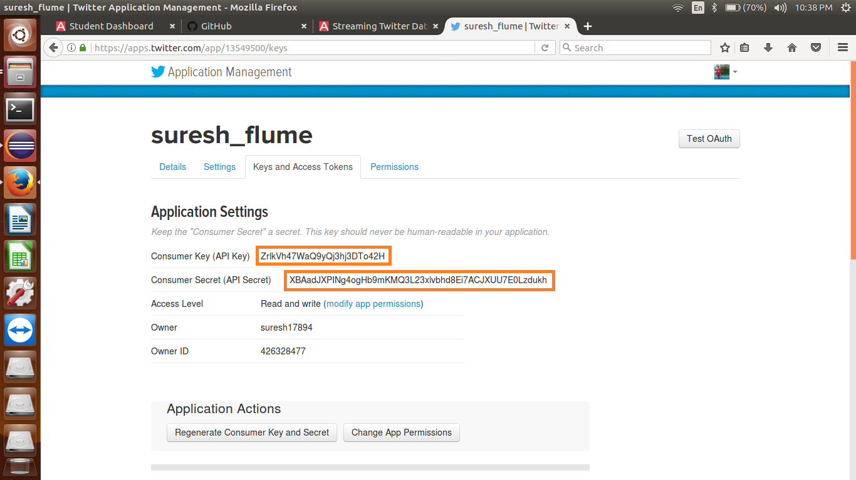

Access Token and Access token Secret code:

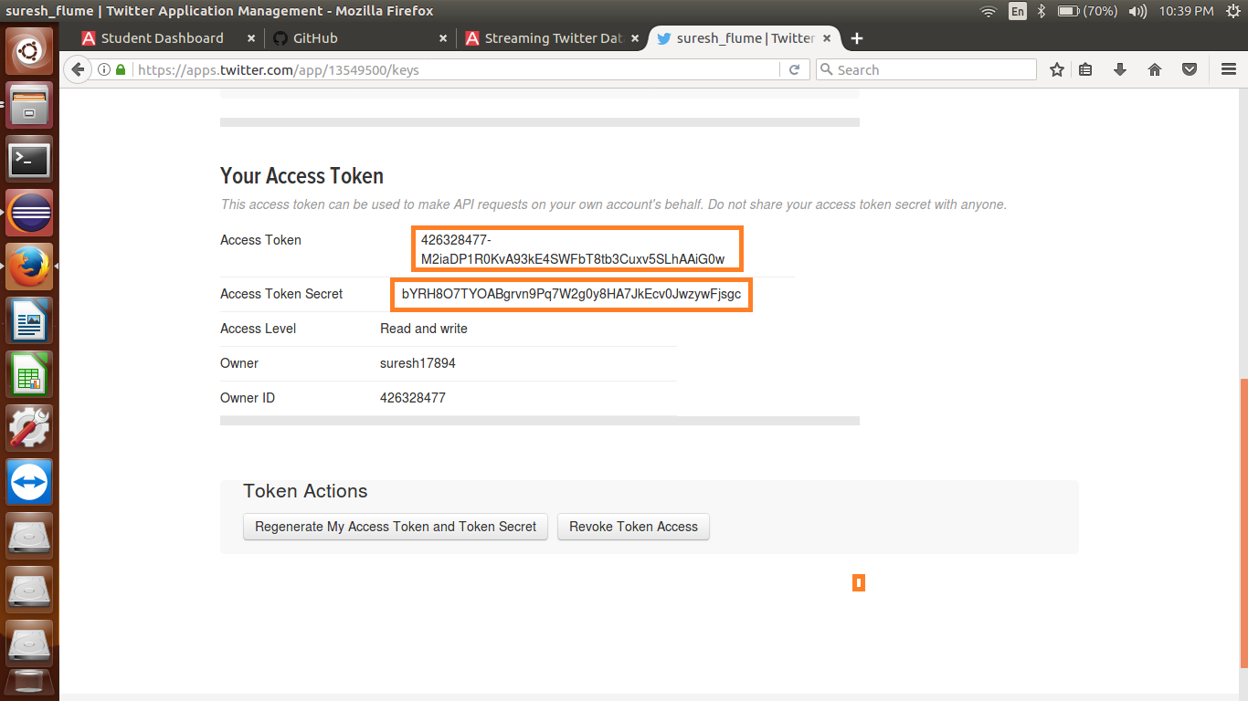

Setting the path of flume directory in bashrc file:

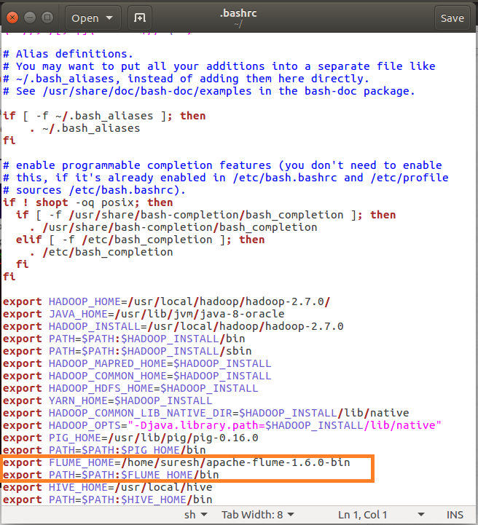

Change the twitter api keys with the keys generated

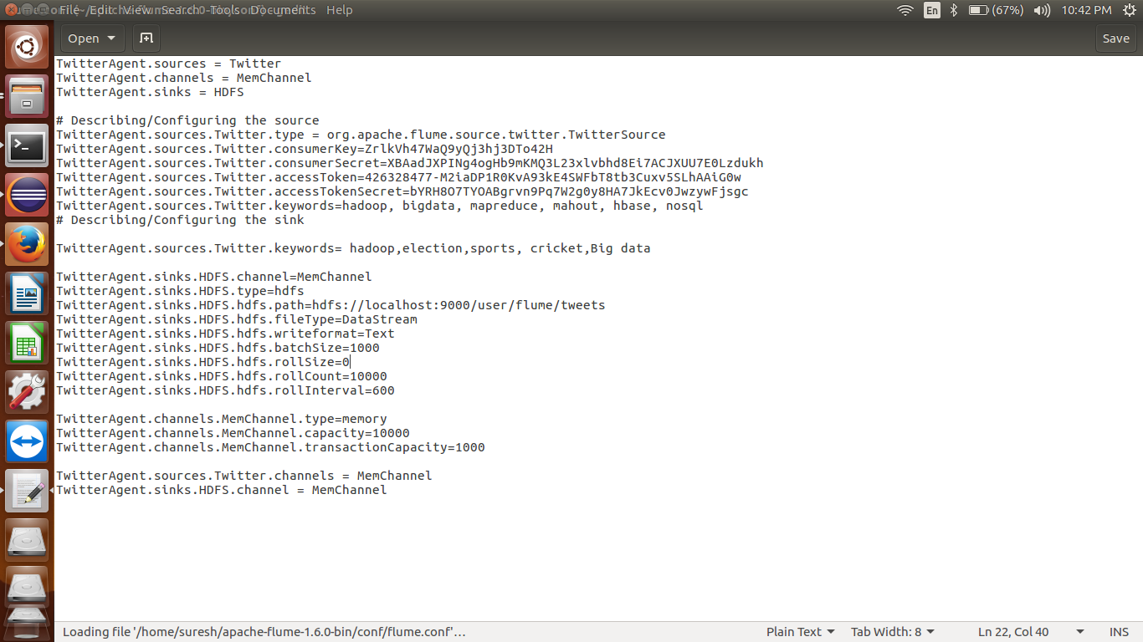

Fetching data from Twitter

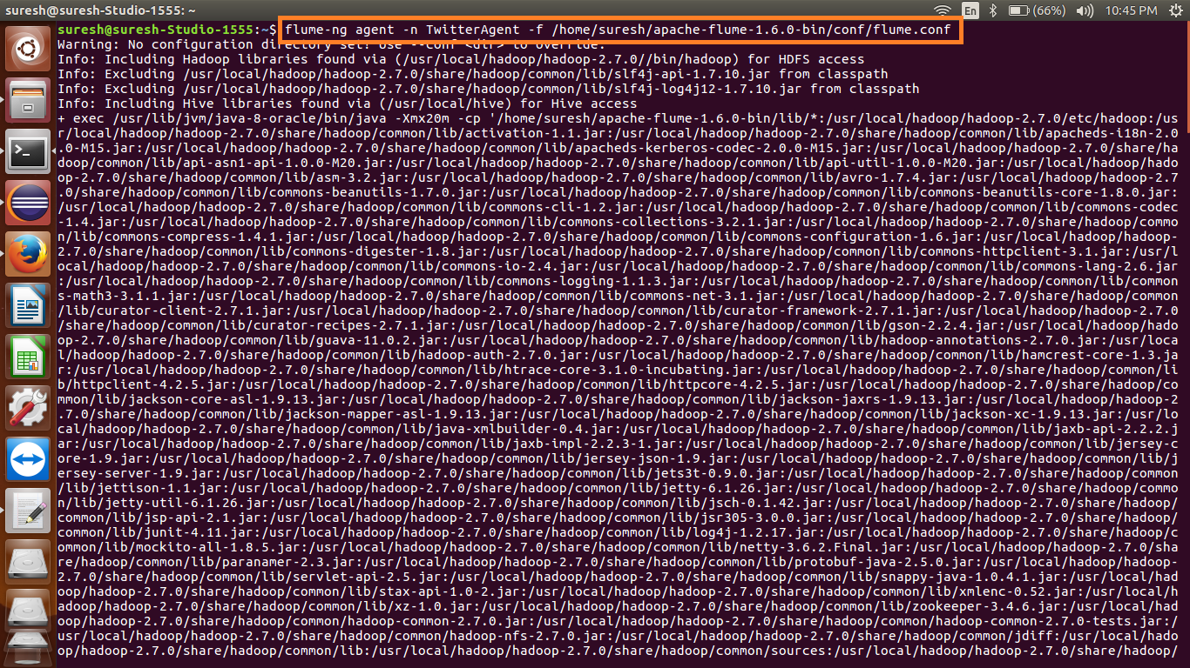

The above command will start fetching data from Twitter and steams it into the HDFS given path.

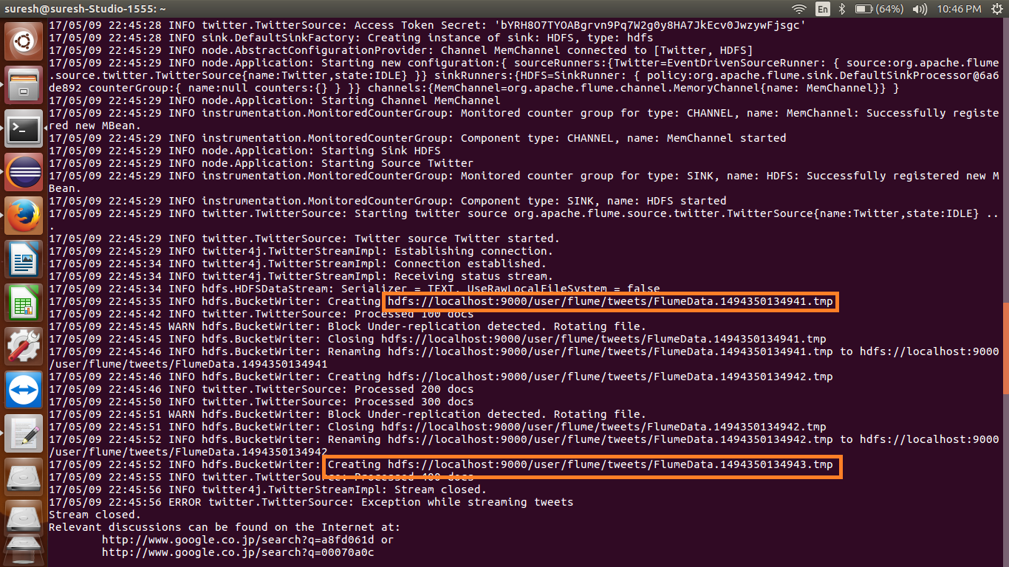

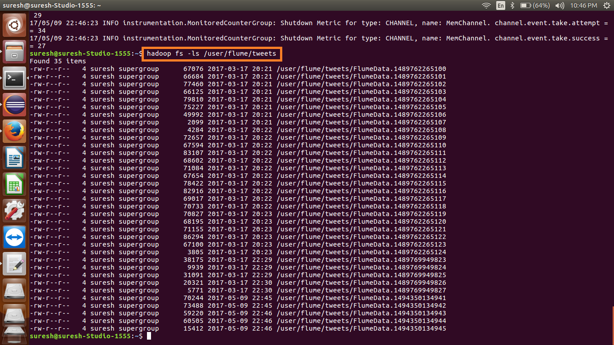

Use the *‘cat’* command to display the tweet data

